History of Yanmar Diesel Engine Co. Ltd.
Many chapters of significant developments
1912
Yamaoka Hatsudoki Kosakusho ( Engine Manufacturing Company), forerunner of Yanmar Diesel Engine Co. Ltd. founded by Magokichi Yamaoka in Osaka.
1921
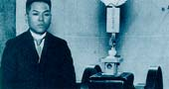
The brand name "Yanmar" adopted. By coupling an engine with a rice huller, Yanmar had a Powered Rice Huller which it started selling. This was the first powered rice huller in Japan.
1927
After becoming involved with Mintol Ironworks in the Philippines, Yanmar started exporting its Horizontal Kerosene Engines to that country.
1928
Commended by Prince Fushimi, the representative of The Japan Industrial Association, for Yanmar's great contribution to Japan's industrial development through the manufacture of engines. Following the ceremony celebrating the succession to the throne of the Showa Emperor, a Yanmar offset type kerosene engine and powered rice huller were purchased by the Emperor's Household Agency for use in the Imperial Family's paddy field.
1930
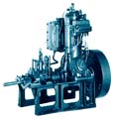
Developed vertical 2-cycle 5 HP Diesel Engine. This was the first diesel engine made by Yanmar, and the first model was purchased by the Ministry of Agriculture. (The engine is now on display in the showroom at the Yanmar Nagahama Plant.)
1933
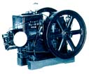
The world's first small horizontal diesel engine Model HB 5-6hp, was developed and went into production.
1936
Large new investments allowed the setting up of production facilities for diesel engines at the Yamaoka Internal Combustion Engine Co. Ltd. on the present Amagasaki Plant site.
1937
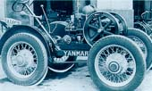
Released "Rikuogo" (Land King) Tiller, New Horizontal Engine and Okada -Type Simple Tractor. These were sold throughout Japan and enjoyed a very high reputation with farmers.
1938
Started exporting Yanmar Diesel Engines to the Philippines and India.
1942
Nagahama Plant established. This is now the main Yanmar plant.
1947
Yanmar's war-damaged plants renovated and the mass production of small marine diesel engines started. These early Yanmar marine diesels practically laid the foundation for the motorization of small Japanese fishing boats.
1948
Re-started exports to South East Asia, as well as to India and Pakistan.
1949
Established Nagahara Precision Plant and started production of parts and components for fuel injection pumps for small diesel engines.
1950
Started exports to Brazil. Commended by the Minister of Trade and Industry on the occasion of the 1st Japan Agriculture Machinery Export Promotion Exhibition. Exports to India greatly expanded.
1951
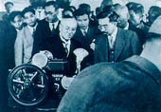
President Magokichi Yamaoka awarded the Blue Ribbon Medal by the Japanese Government for Yanmar's meritorious deeds in developing industry and for its contributions to improvements in the standard of living. Awarded First Prize at the 2nd General Purpose Internal Combustion Engine Contest organized and sponsored by the Ministry of Trade and Industry.
1952
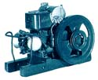
Company name changed to Yanmar Diesel Engine Company Limited and recapitalized at 300 million yen. The world's smallest 4-cycle horizontal water-cooled engine developed.
1955
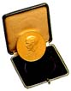
President Magokichi Yamaoka was awarded the Gold Diesel Medal by the Inventors' Association of Germany for his invention of the small diesel engine.

1956
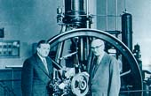
In response to a request, President Yamaoka donated an example of the world's smallest diesel engine to the German National Museum.
1957
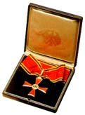
A 100% Yanmar-owned company ( Yanmar Diesel do Brasil Ltda. ) was set up in Sao Paulo, and started local production and marketing. President Yamaoka was awarded the Great Cross Medal for Meritorious Service by the Ambassador of the Federal Republic of Germany, in recognition of his contribution to Japanese-German relations. Nagahama, as a designated JIS plant, was commended by the Ministry of Trade and Industry for its contribution to industrial standardization and quality control.
1961
Yanmar concluded a technical licensing agreement on rotary engines with Wankel and N.S.U. in West-Germany. Yanmar Agricultural Equipment Co. Ltd. established in Osaka to expand sales of agricultural-use diesel engines.
1962
Vice-President Yasuhito Yamaoka assumed Executive Directorship and Presidency.
1963
Executive Managing Director Tadao Yamaoka assumed Presidency upon the death of his brother.
1966
Yanmar concluded sales and service agreement with Rolls Royce. Yanmar service station opened in Bangkok, Thailand.
1967
Yanmar ( Malaysia) Snd. Bhd. established in Kuala Lumpur. Kinomoto plant established and started production of small diesel tractors.
1968
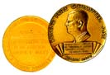
Yanmar awarded the prestigious Demming Prize, the first time it was given to a Japanese diesel engine manufacturer. Vietnam Power Products ( VINAPRO ) established in Saigon.
1970
Yanmar entered into sales agreement with Perkins Engines Ltd., U.K. and began sales of "Yanmar-Perkins" engines.
1972
P.T. Yanmar Diesel Indonesia established in Jakarta, Indonesia.
1975
Europe Liaison Office opened in London. P.T. Yanmar Agricultural Machinery Manufacturing Indonesia established in Pandaan, East Java, Indonesia.
1976
Rotterdam Liaison Office opened in the Netherlands. Yanmar Agricultural Machinery Corporation ( YAMACO ) established in Manila.
1977
Yanmar-John Deere Engineering Yugengaisha ( Limited Company ) established. Liaison Office opened in Piraeus, Greece.
1978
Amagasaki Plant received certification as an engine manufacturer by both the American Bureau of Shipping and Lloyd's Register. This became the first factory in Japan to receive certification from all of ABS, Lloyds and also the Nippon Kaiji Kyokai ( NK ). Yanmar Thailand Co. Ltd. established in Bangkok.
1979
Yanmar Tractor ( U.S.A.) Inc. established in Illinois.
1980
U.S.A. Liaison Office opened in Chicago. Singapore Liaison Office opened.
1981
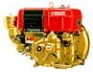
Production of horizontal water-cooled small diesel engines topped 5 million units, a world record. U.S.A. Liaison Office incorporated; Yanmar America Corp. established.
1982
Yanmar's 70th birthday. 70th Anniversary celebrated at the newly completed Yamaoka Memorial Building in Osaka.
1983
The HWC 50 years old and still going strong. Cairo Liaison Office opened.
1984
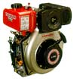
Yanmar Diesel Engine ( U.S.A. ) Inc. established in Anaheim. Developed the world's smallest air-cooled diesel L series ( 4.2 - 6.0 hp.)

1985
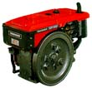
Release of the TF series, all-new horizontal water-cooled small diesels. The new multi-purpose industrial diesels, TN series ( 16.5 - 45 hp ) released.

1986
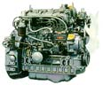
Total tractor shipments to Deere & Co. in the U.S. pass the 100,000 mark.

1987
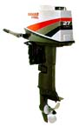
Pace-setting D27 series diesel outboard. Post-war diesel engine production tops 8 million.
1988
Yanmar S.P. Co. Ltd. established in Bangkok, Thailand. L-Series shipments exceed 100,000.
1989
Yanmar Europe B.V. established with its base in the Netherlands. Tuff Torq Corp. established in Tennessee, U.S.A.
1991
Yanmar Asia ( Singapore ) Corp. Pte. Ltd. established in Singapore.
1992
Yanmar celebrated 80th anniversary. Amagasaki & Nagahama plants received ISO 9001 certification. Post-war production reached 10,000,000 units.
1996
Production starts in Chicago Yanmar Diesel America.
1997
Production of marine engines in Yanmar Europe Netherlands.
1997
Yanmar announces cooperation with Mercruiser.

